GUJARAT TECHNOLOGICAL UNIVERSITY

Chandkheda, Ahmedabad

Affiliated

 

**New L J Institute of Engineering and Technology**

A

Project Report

On

**“YOUTH EMPLOYMENT OPPORTUNITIES”**

Under subject of

DESIGN ENGINEERING-2A

B. E., Semester – V

Computer Science Engineering (Artificial Intelligence & Machine Learning)

Submitted by:

**Group: CSE-24 ID: 388162**

**Sr No. Name of student Enrollment No**.

1. UNNATI JAGDISH PARIKH 201430142005
2. DIYA RAKESHKUMAR BODIWALA 201430142062
3. KSHITI PRANAV MULANI 201430142077
4. SHASHVI KAUSHALBHAI SHAH 201430142127

**Prof. Mohit Patel**

(Faculty Guide)

**Dr Gayatri Pandi**

(Head of the Department)

Academic Year: 2022-2023

**CERTIFICATE**

This is to certify that the project work embodied in this report entitled **“YOUTH EMPLOYMENT OPPORTUNITIES”** was carried out by below mentioned students at the department of CSE(AIML), New L.J. Institute of Engineering and Technology, Ahmedabad for partial fulfilment of the subject design engineering 2A. This project work has been carried out under my supervision and is to the satisfaction of the department.

|  |  |  |
| --- | --- | --- |
| **Sr.** | **Name of Student** | **Enrolment No.** |
| 1 | UNNATI JAGDISH PARIKH | 201430142005 |
| 2 | DIYA RAKESHKUMAR BODIWALA | 201430142062 |
| 3 | KSHITI PRANAV MUALNI | 201430142077 |
| 4 | SHASHVI KAUSHALBHAI SHAH | 201430142127 |

INTERNAL GUIDE SIGN HOD SIGN COLLEGE SEAL

**ACKNOWLEDGMENT**

I cannot express enough thanks to my support members for their continued support and encouragement: **Dr Gayatri Pandi** (HOD), and **Mr Mohit Patel** (Guide). I offer my sincere appreciation for the learning opportunities to my support members.

The completion of this project could not have been accomplished without the support of the team members. A special thanks go to my team members. They helped me to assemble the parts and gave suggestions about the project.

Besides, we would like to thank all the teachers who helped us by giving us advice and providing the material required. I would like to thank my family and friends for their support. Without that support, we couldn’t have succeeded in completing this project. In the end, we would like to thank everyone who helped and motivated us to work on this project.

**ABSTRACT**

Youth Employment Opportunities is a project that discusses the unemployment issue in, covering which covers a large part of India. It discusses the problems faced by the youth in rural areas due a to lack of proper knowledge and guidance.

Although with the increase in school and college enrolment rates, the proportion of youth in the labour force has been declining, their high proportions in the labour force indicate that the problem of youth unemployment and underemployment would remain a serious issue in India for many years to come. From a social point of view, unemployment means the wastage of precious labour resources in the country.

For an individual, unemployment is a painful and demoralizing experience, especially for the youth who possess the skillset but are unable to use it for themselves and for the betterment of their families.

In this context, the project offers recommendations for increasing productive employment and reduction in unemployment for the youth.

**LIST OF TABLES**

Table 1 Project Summary…………………………………………………...…………………5

Table 2 Difficulties faced to get employed……………………………………………….……6

Table 3 Distribution of workers by Industry Category and Sector in India……………………6

**LIST OF FIGURES**

Figure 1 – Indeed interface (the first page)………………………………2

Figure 2 – Indeed interface (the tools available) ……………...…………3

Figure 3 – LinkedIn interface…………………………….………………3

Figure 4 – The API obtained from various job sites…..…………………4

* 1. – Homepage……………………………………….…….....5
  2. – Jobs Section …………………………………….……….5

Figure 5 – AEIOU Canvas………………………….……………………7

Figure 6 – MindMap……………………………..………………………8

Figure 7 – Empathy Canvas…………...…………………………………9

Figure 8 – Ideation Canvas………………………………………………10

Figure 9 ­– Prototype….………………………………………………….11

Figure 10 ­– Product Development Canvas………………………………12

Figure 11– Learning Need Matrix Canvas……………………………….13

**LIST OF ABBREVIATIONS**

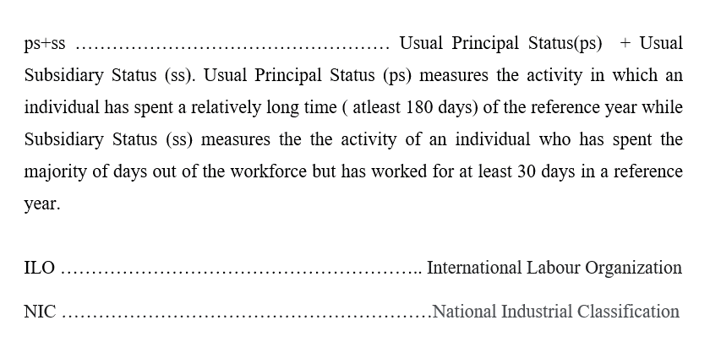

**INDEX**

|  |  |  |
| --- | --- | --- |
| **Sr.** | **Title** | **Page No.** |
| **1** | **Introduction**  Phase 1: Reverse Engineering (RE): Selection and disassembling of art fact/component)  Phase 2: Disassembly / Analysis of the component/product/art fact/program and learning about the topic | **1** |
| **2** | **Project Summary** | **6** |
| **3** | **AEIOU Canvas** | **8** |
| **4** | **Mind Map Canvas** | **9** |
| **5** | **Empathy Canvas** | **10** |
| **6** | **Ideation Canvas** | **11** |
| **7** | **Product Development Canvas** | **12** |
| **8** | **Rough prototype Model** | **13** |
| **9** | **Learning Need Matrix** | **14** |
| **10** | **Feedback Analysis** | **16** |
| **11** | **Conclusion** | **17** |
| **12** | **References** | **18** |

1. **INTRODUCTION**

**Phase 1: Reverse Engineering (RE): Selection and disassembling of art fact/component)**

Job sites serve as modern tools of many advertisements by compiling them and listing available telecommunications and local facilities. Job sites gather thousands of job openings in one convenient place and can refer a person to positions and companies that one otherwise may not have known about. At their core, job sites act as both search engines and databases for open jobs. Job sites can help educated and experienced candidates find work in any field.

Some of the job search websites are[1]:

1. Indeed
2. Monster
3. LinkedIn
4. Glassdoor
5. FlexJobs
6. Ladders
7. Naukri.com
8. AngelList

Indeed, post listings for job seekers in every industry, every level, and every lifestyle like freelance, part-time, internship or full-time. One needs to create an account in order to apply for some job listings. Some sites also offer salary comparison and research tools and provide premium resume makeups like Monster.

LinkedIn acts as a database for open opportunities, a digital resume platform, and an all-in-one social networking tool. FlexJobs specializes in remote opportunities with no scams and no ads.

Ladders serves as a job site, career newsroom and networking platform. AngelList was founded in 2010 as a way to democratize the way startups get funding and hire talent. Today, it offers an unprecedented level of transparency by providing candidates with upfront salary and equity options upfront, as well as information about key figures in the company.

One can know the culture and salary data of each company, which makes Glassdoor the best place to research and better place for employers.

But more specialized or niche job sites may not be right for every candidate, in every industry, skill level, and zip code.

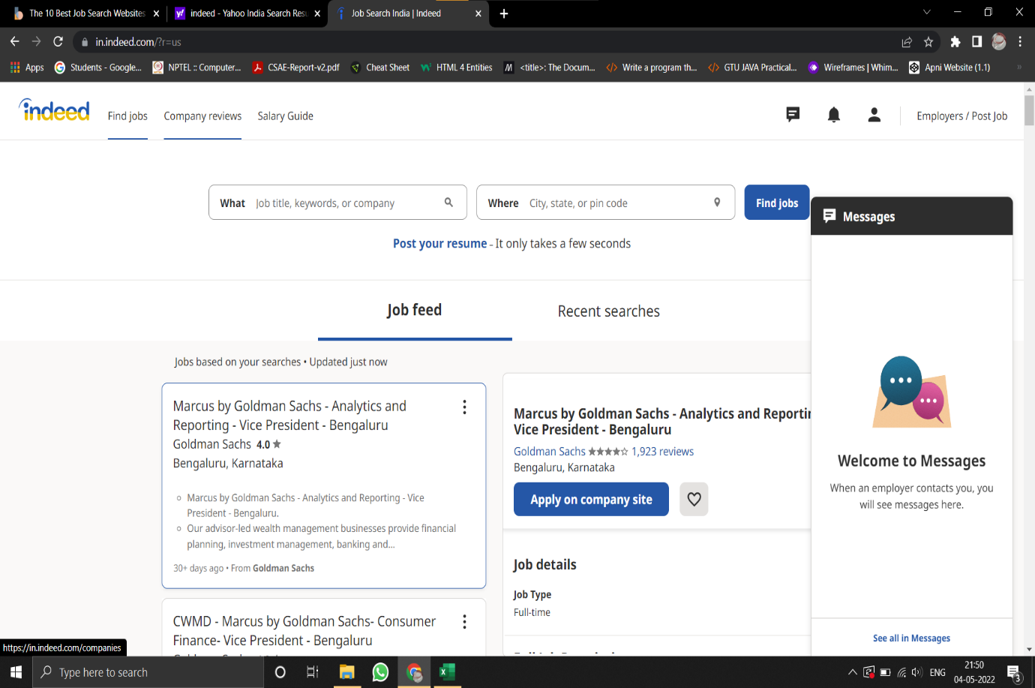



**Figure 1 – Indeed interface**

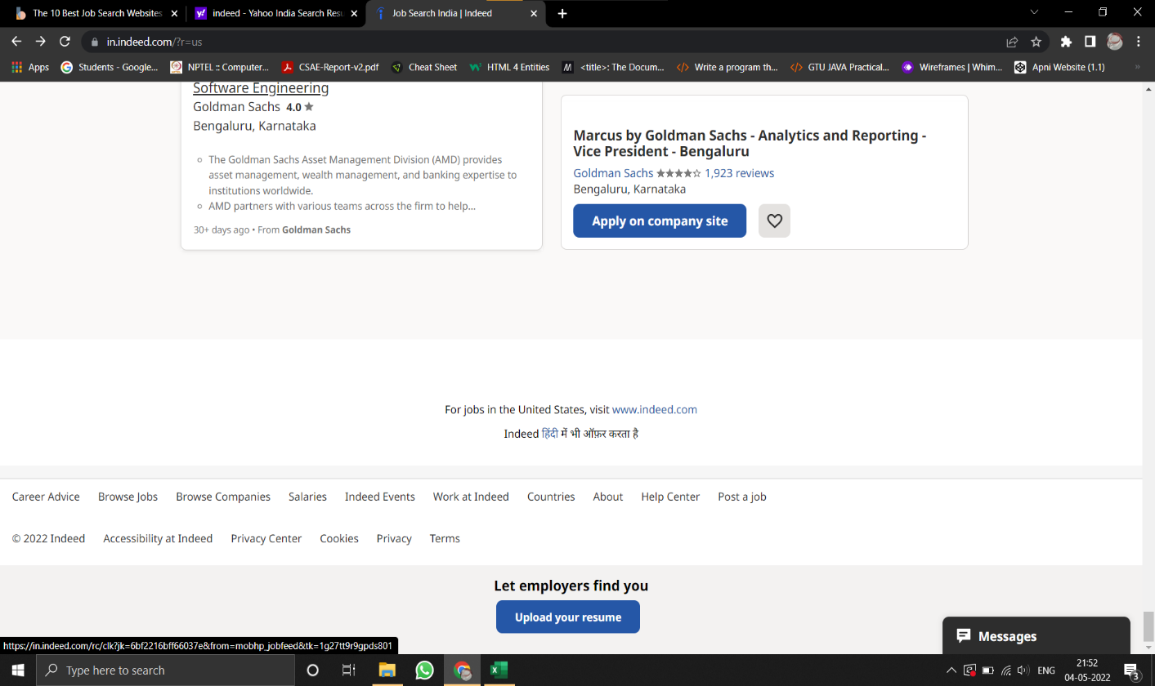

**Figure 2 – Indeed Interface**



**Figure 3 – LinkedIn Interface**[2]

**Phase 2: Disassembly / Analysis of the component/product/art fact/program and learning about the topic**

These websites mainly include features like search bars through various filters like

* Job Titles
* Location
* Salary Range
* Date Posted
* Experience

They also constitute sign–in through free logins or paid subscriptions with premium access. Message sections or chatbots are also available here. Alerts through messages or emails are also made possible through login ids. But the attraction of these websites includes salary information and comparison tools to search for various jobs and cities wise salaries.

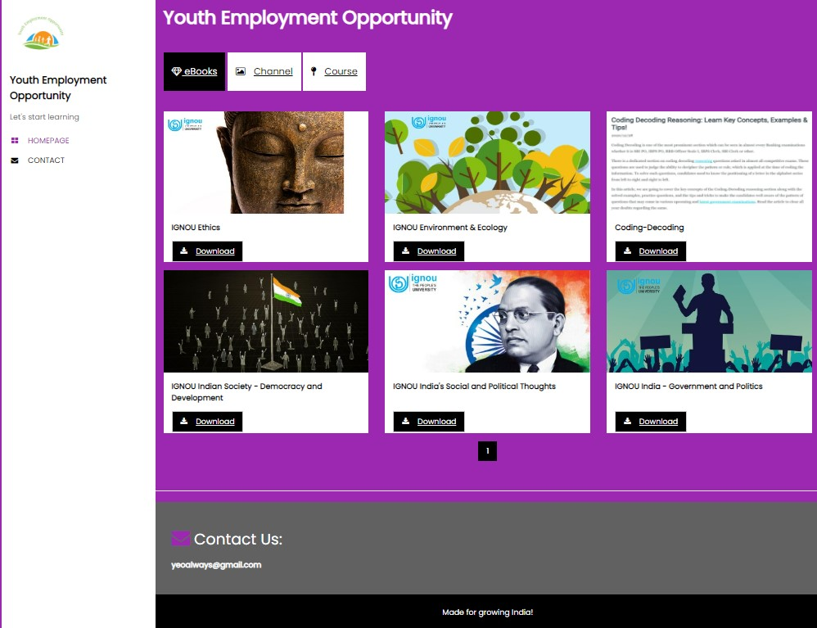

**Figure 4.1 – The API obtained from various job sites**



**Fig 4.2 - Homepage**

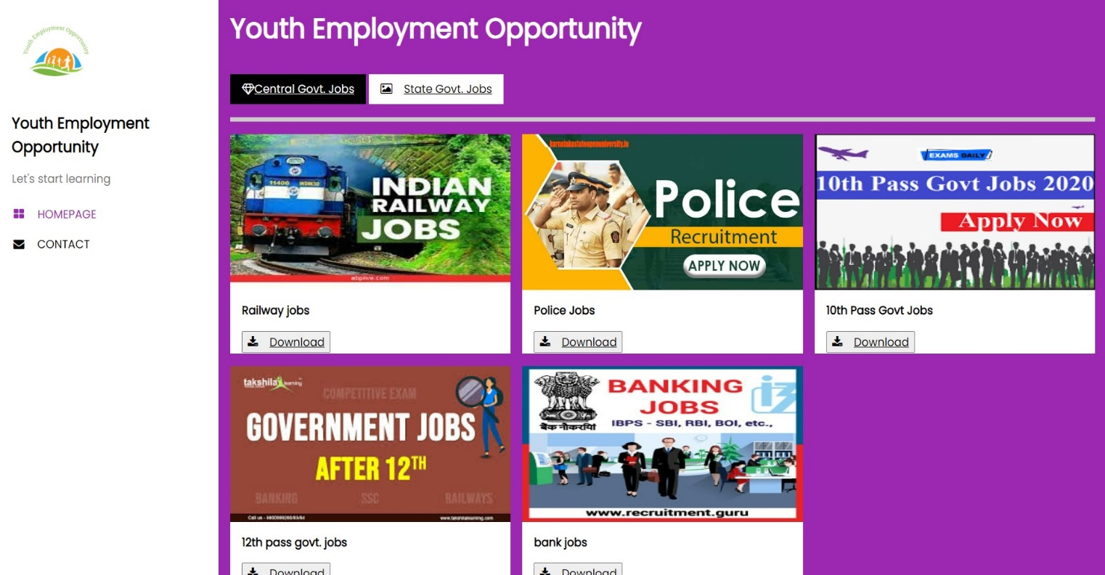

**Fig 4.3 - Jobs section**

1. **PROJECT SUMMARY**

|  |  |  |  |  |
| --- | --- | --- | --- | --- |
| **Sr no.** | **Paper Title** | **Paper Author** | **Published Year** | **Summary** |
| 1 | The evidence is in: How should youth employment programs in low-income countries be designed? | Louise Fox and Upaasna Kaul | 2017 | This research examines the barriers to youth transitioning into work in low-income nations. It looks at which employment initiatives and policies appear to help youth make the transition faster, with a focus on establishing new job opportunities for them.[3] |
| 2 | Opinion of youth on issues and challenges related to Employment: A study in Mysore city | Dr Mohan A.K | 2016 | Unemployment rates are normally considered as employment inadequacy for youth. In India, from 2000-to 2010 the share of employment in the industry and service sector continued to grow while agriculture employed fewer workers. Poor quality of educational services is producing a workforce lacking the basic knowledge and skills needed for today's job.[4] |
| 3 | Challenges Of Decent Employment In India | Shamim Ara | 2021 | This article examines employment challenges in India in the ILO’S decent work framework.  Remarkably, jobs were created in the organized sector, in the regular salary category, and in the services sector in 2017-18. However, the rate of employment growth in these segments is very low and cannot offset the net loss of employment in the unorganized sector, temporary jobs and agriculture and manufacturing, particularly in rural areas. The article advocates for urgent policy interventions to ensure access to productive and decent work for all in India.[5] |

**Table 1 Project Summary**

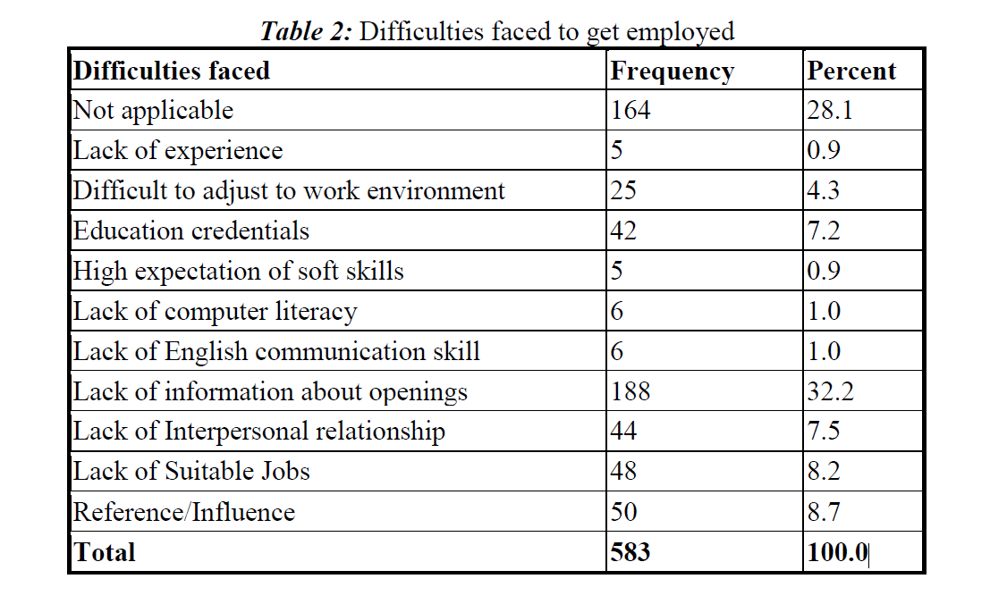

**Table 2: Difficulties faced to get employed**[4]

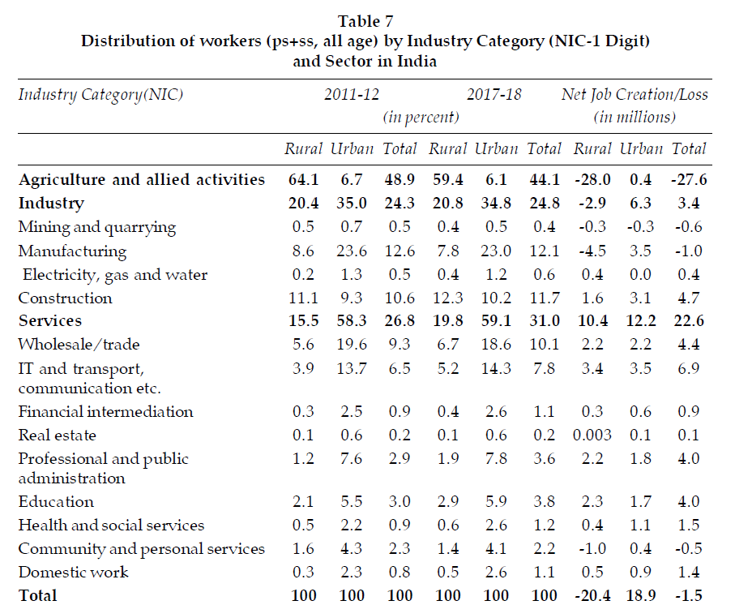

**Table 3 Distribution of workers by Industry Category and Sector in India**[5]

1. **AEIOU CANVAS**

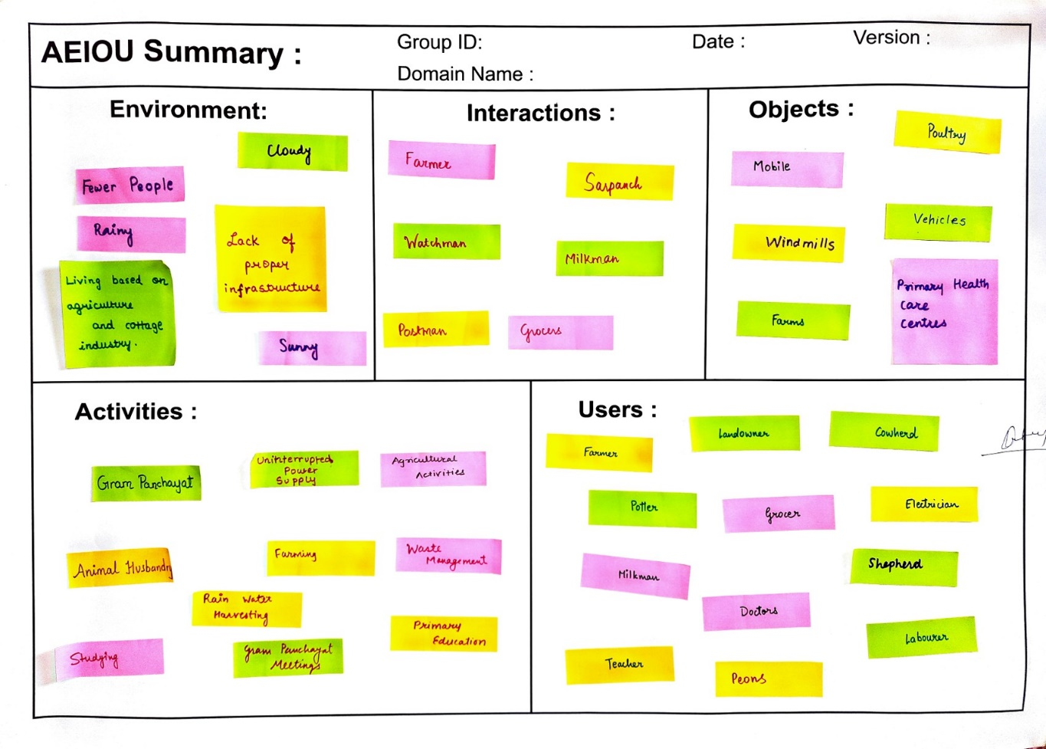

**Figure 5 AEIOU Canvas**

1. **MIND MAP CANVAS**

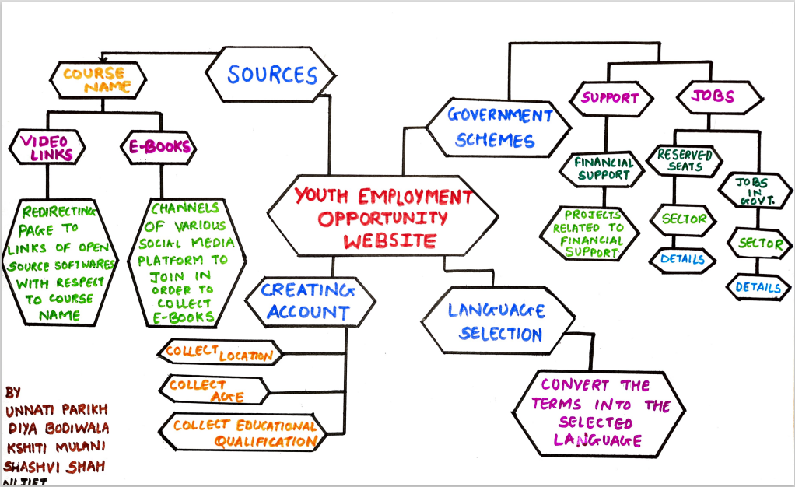

**Figure 6 MindMap**

1. **EMPATHY CANVAS**

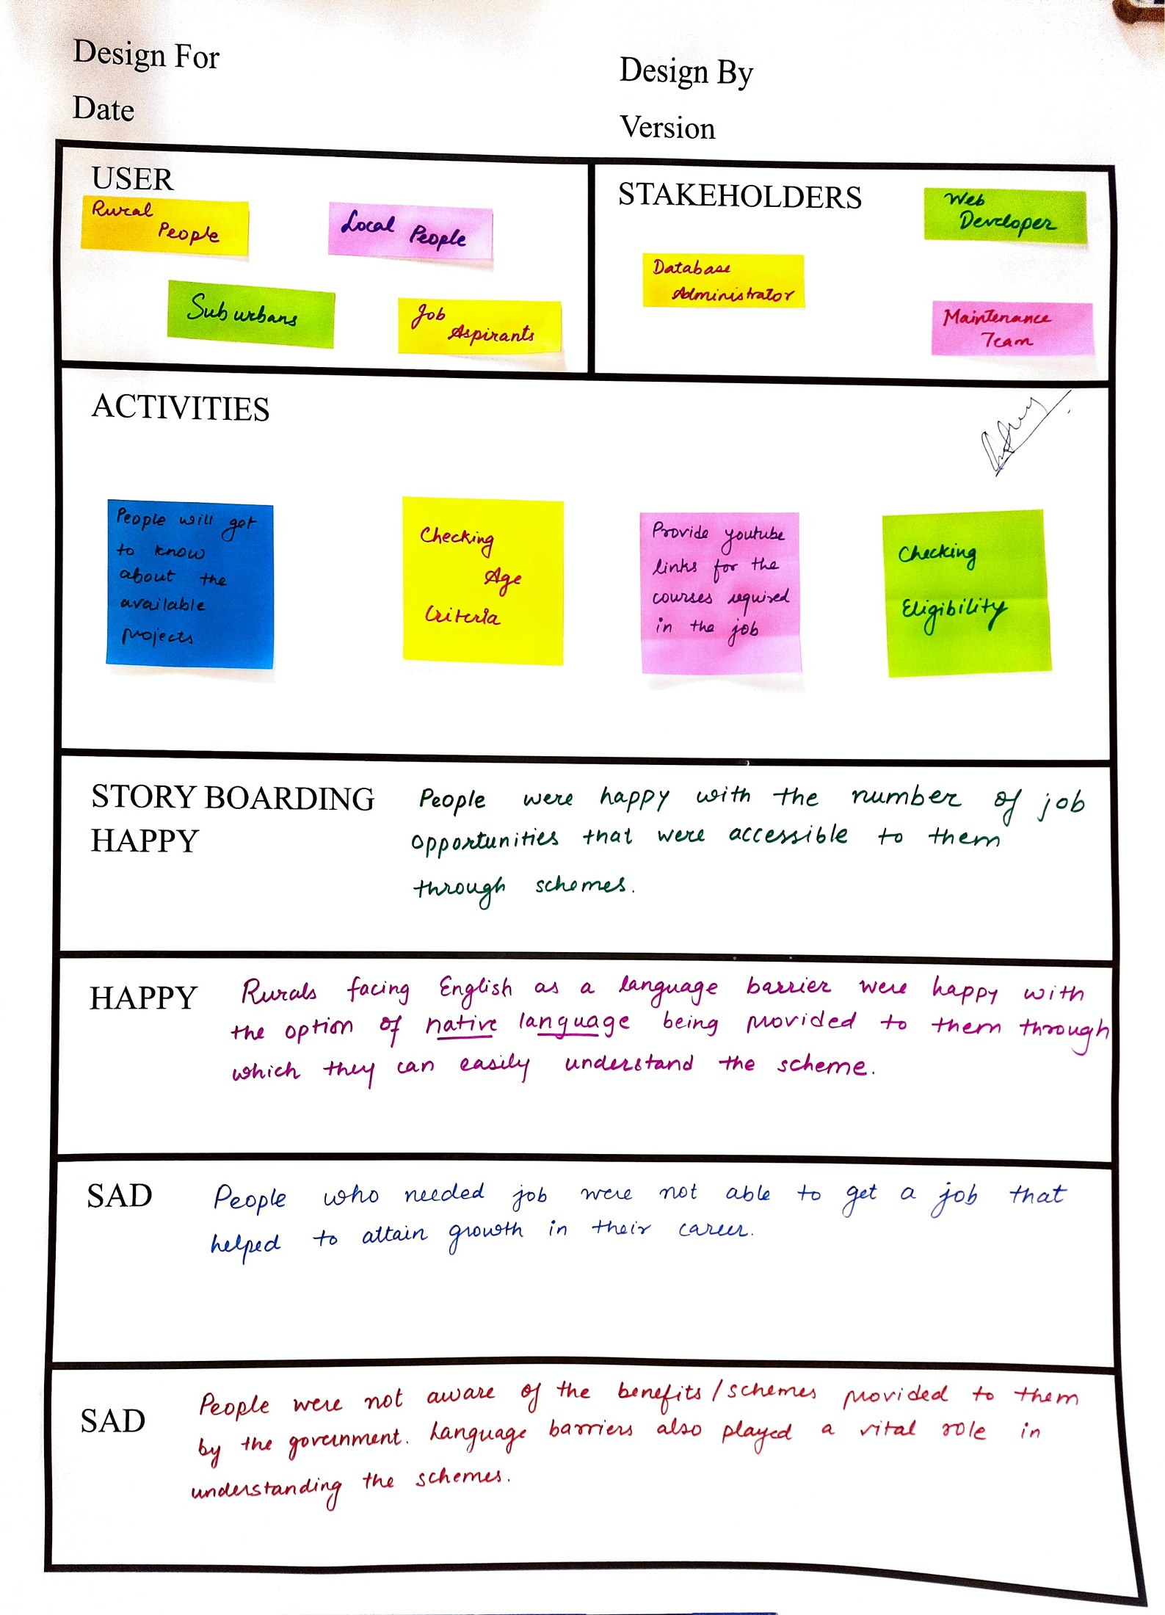

**Figure 7 Empathy Canvas**

1. **IDEATION CANVAS**

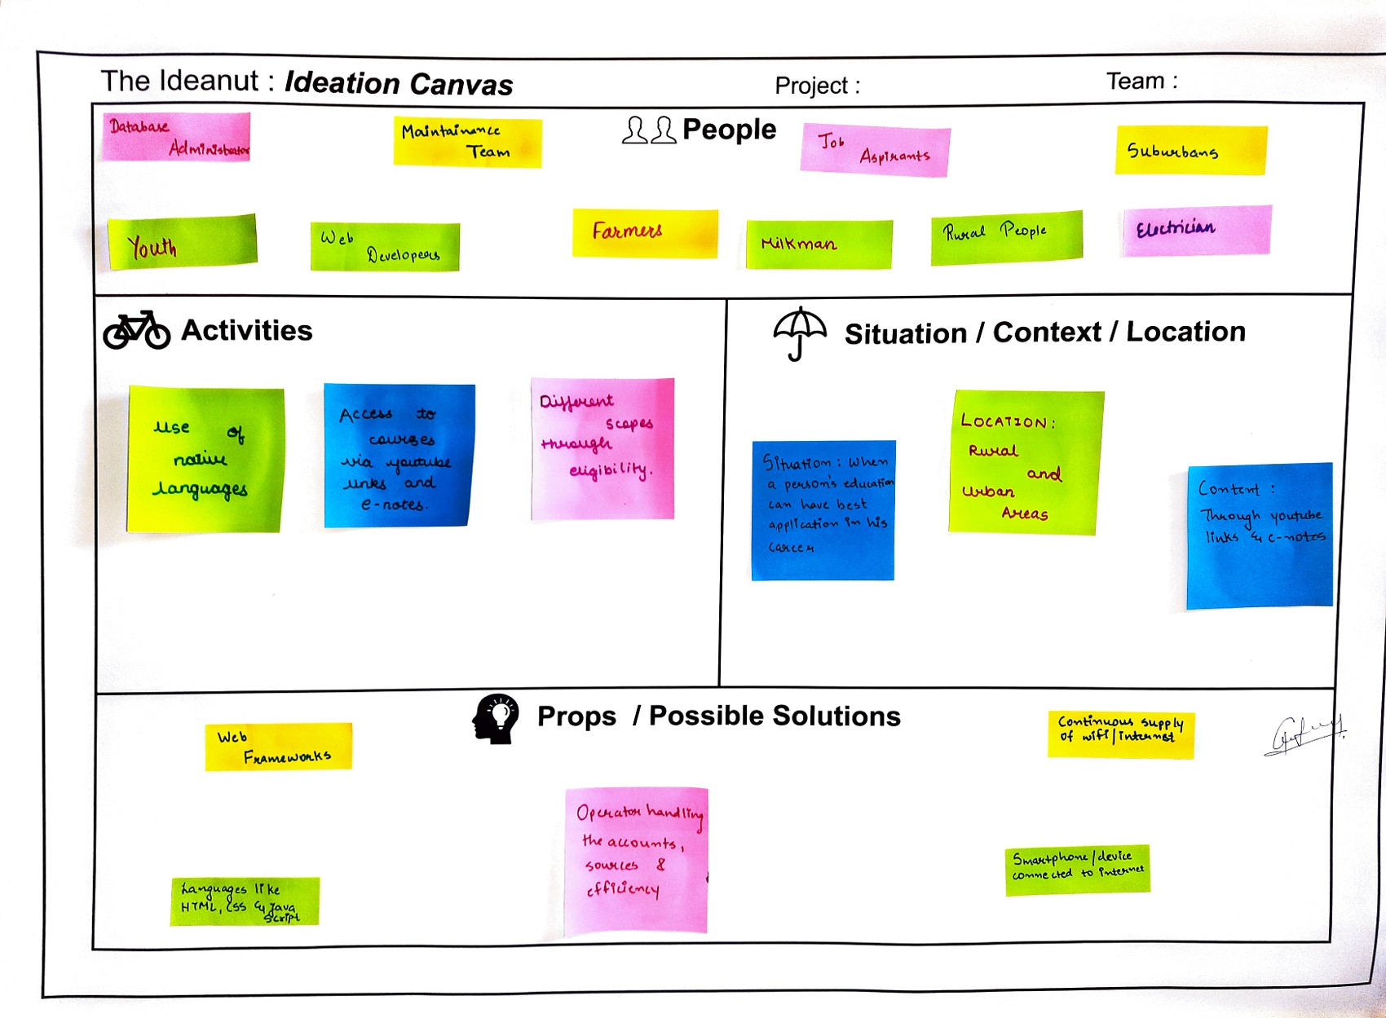

**Figure 8 Ideation Canvas**

1. **ROUGH PROTOTYPE MODEL**

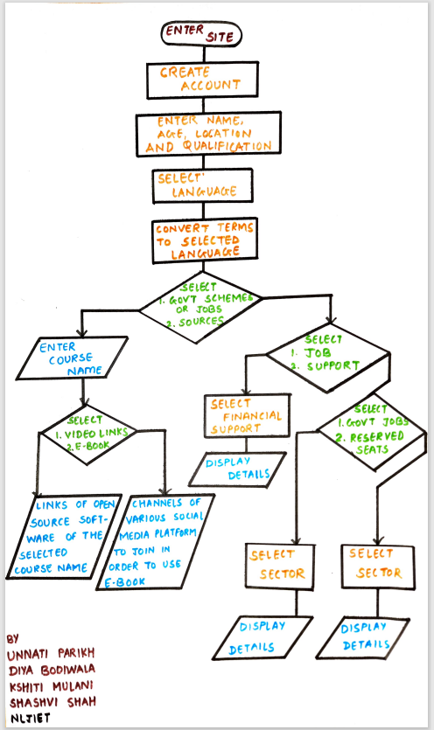

**Figure 9 Prototype**

1. **PRODUCT DEVELOPMENT CANVAS**

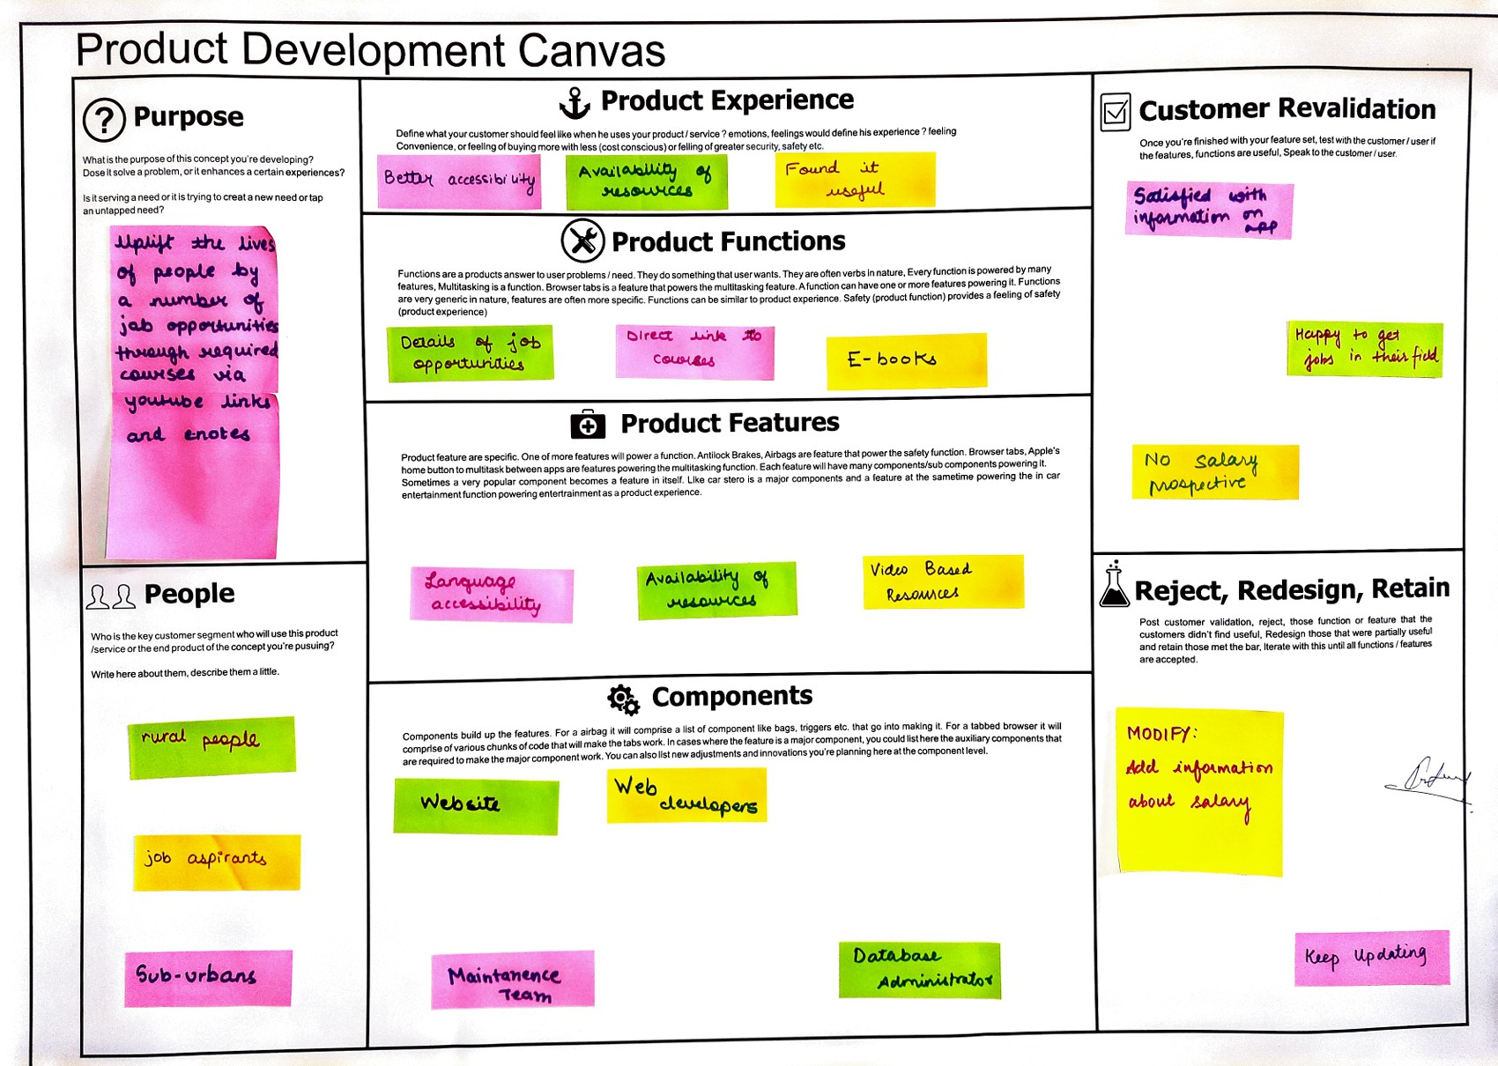

**Figure 10 Product Development Canvas**

1. **LEARNING NEED MATRIX**

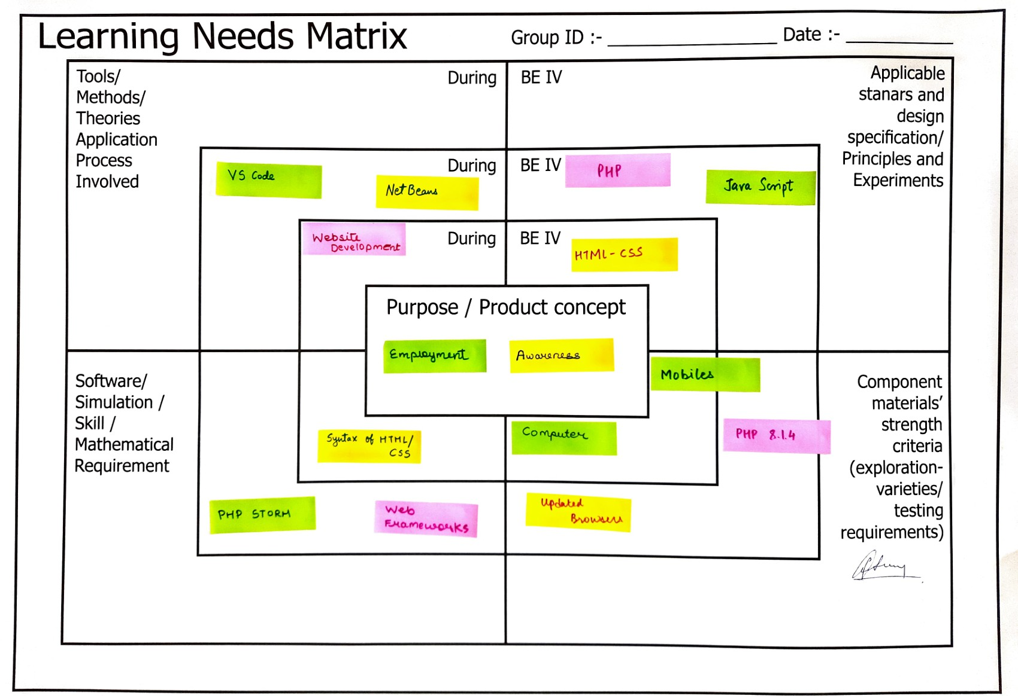

**Figure 11 Learning Need Matrix**

* **Purpose/ Product Concept**

**It includes the main idea behind the design.**

* Employment
* Awareness
* **Tools/Method/Theory/Application Process Involved**
* Website Development - It provides the basis for social interaction between the candidate and the party by being a middleman and provides easy access to employment for even ordinary people.
* **Applicable standards and design specifications/ Principles & experiments**
* JavaScript -  used by programmers worldwide to create dynamic and interactive web content such as applications and browsers. It allows you to make web pages interactive.
* HTML-CSS - HTML is a language for describing the structure of Web pages and CSS is a language for describing the presentation of Web pages, including colors, layout, and fonts.
* PHP - PHP allows web developers to create dynamic content and interact with the database. PHP is known for its simplicity, speed, and flexibility – features that have made it fundamental in the world of web development.
* **Component materials strength criteria (exploration – varieties/testing requirements)**
* Mobiles
* Computer
* PHP 8.1.4
* Updated browsers
* **Software/Simulation/Skill/Mathematical Requirement**
* Visual Studio - Visual Studio is an integrated development environment used to develop console and graphical user interface applications along with Windows Forms applications, websites, applications and web applications and web services using native and managed code.
* PHPStorm - PHPStorm is a proprietary, cross-platform IDE that provides an editor for PHP, HTML and JavaScript with rapid coding analysis. It also helps with error prevention and automatic refactoring of JavaScript and PHP code.
* WebFrame Works – A web framework is a software framework designed to aid in the development of web applications including web services, web resources, and web APIs. Web frameworks provide a standard way to build and deploy web applications on the World Wide Web.

1. **FEEDBACK ANALYSIS**

We proposed our project to the clients. The idea was appreciated but retained. They helped us to gain more insight into our project with the ideas like

* Adding salary prospects
* Adding comparison tools to compare various openings according to location, experience and salary
* To think of a wider domain to include other lifestyles like freelancing, internships along with part-time and full-time jobs.

This also leads us to search more for the same.

This project can also include

* Message facilities or chatbot
* Reviews about the company or workplace.
* Notifications for updates.

1. **CONCLUSION**

The project **Youth Employment Opportunities** has the following conclusions:

* The quality of training and education affects young people’s job opportunities. We can therefore carry out research studies to find out what factors can affect the employment status of young people.
* Unemployment is mainly caused by the lack of suitable opportunities and training facilities. Other personal and cultural issues also play a role in this. We should make sure that the youth get the proper skills training and all the necessary information easily.
* We can run programs that can help young people easily enter and make money in the household products sector. We can also place more emphasis on policies and projects that increase the number of modern labour-intensive companies by helping them grow and hire more workers [3].
* The analysis in the paper supports the need to create more jobs by integrating employment targets into development strategies and the sector, which has high long-term resilience. Manufacturing in general, micro-enterprises in particular and tourism should be targeted.
* They have the potential to create more jobs by absorbing semi-skilled, skilled and all types of workers.
* Hiring, promotion and working conditions without gender discrimination are commendable steps in this direction**.**[5]

1. **REFERENCES**
2. WEBSITES

[1] E. POLNER, “Best Job Search Websites,” 25 March 2022. [Online]. Available: <https://www.thebalancecareers.com/top-best-job-websites-2064080>

[2] [Online]. Available: <https://s.yimg.com/uu/api/res/1.2/uRSu1p58rPcKG6Q93hjz8Q--~B/Zmk9ZmlsbDtoPTQyMjt3PTY3NTthcHBpZD15dGFjaHlvbg--/https://s.yimg.com/uu/api/res/1.2/hlJmyuH8zqaYRc23UPbfaw--~B/aD0xODAwO3c9Mjg4MDthcHBpZD15dGFjaHlvbg--/https://o.aolcdn.com/hss/storage/midas/132c135e094295a6b8b84c997fa9682f/204831264/Feed+%281%29.png.cf.webp>

2. PAPERS

[3] Fox,Louise & Kaul,Upaasna, 2018. "[**The evidence is in : how should youth employment programs in low-income countries be designed ?**](https://ideas.repec.org/p/wbk/wbrwps/8500.html)," [Policy Research Working Paper Series](https://ideas.repec.org/s/wbk/wbrwps.html) 8500, The World Bank.

[4]Dr. Mohan A.K, “OPINION OF YOUTH ON ISSUES AND CHALLENGES RELATED TO EMPLOYMENT: A STUDY IN MYSORE CITY” International Journal of Research – Granthaalayah, Vol. 4, No. 4 (2016): 1-7. <https://www.cukerala.ac.in/cukpdfs/IQAC/3.4.5/3.4.5.DSW.027.pdf>

[5] Shamim Ara (2021). Challenges of Decent Employment in India. Indian Journal of Finance and Economics, Vol. 2, No. 2, pp. 163-185. <https://arfjournals.com/image/catalog/Journals%20Papers/IJFE/No%202%20(2021)/5_Shamim_Final.pdf>